H.T No
Regulations:
A15

Sreenidhi Institute of Science and Technology
(An Autonomous Institution)
Code No:5B621 Date: 25-Oct-2021(AN)

B.Tech III-Year II- Semester External Examination, Sept/Oct - 2021 (Supplementary)

CAD/CAM (ME)
Time: 3 Hours Max.Marks:75

Note: a) No additional answer sheets will be provided.
b) All sub-parts of a question must be answered at one place only, otherwise it will not be valued.
c) Missing data can be assumed suitably.

ANSWER ANY 5 OUT OF 8 QUESTIONS. EACH QUESTION CARRIES 15 MARKS.

Bloom's Cognitive Levels of Learning (BCLL)

Remember | L1 | Apply | L3 | Evaluate | L5
Understand | L2 | Analyze | L4 | Create | L6

 |  |  | BCLL | CO(s) | Marks
1. | a) | Describe with the help of block diagram the CAD process. | L1 | CO1 | [8M]
 | b) | Explain the principle of working of CRT display device with suitable diagram. | L2 | CO1 | [7M]
2. | a) | What do you mean by database structure? Discuss the popular database model with suitable example. | L1 | CO2 | [8M]
 | b) | Explain how the 2-D transformations are used for translation and rotation. | L2 | CO2 | [7M]
3. | a) | Describe with the help of neat sketches the major surface entities provided by the CAD/CAM systems. | L1 | CO3 | [9M]
 | b) | Write short notes on:  i) Basic geometric commands  ii) Editing  iii) Dimensioning | L1 | CO3 | [6M]
4. | a) | Write a manual part program using NC word address format to drill the holes in the work piece shown in Fig.1. The work piece thickness is 10mm. select the suitable speed and feed values.  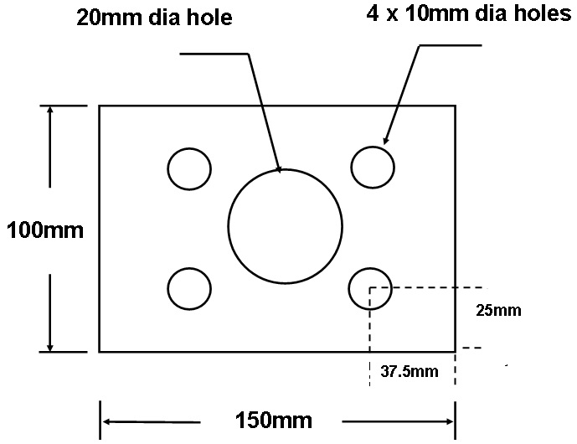  Figure.1 | L1 | CO4 | [8M]
 | b) | Discuss the basic elements of numerical control system. | L2 | CO4 | [7M]
5. | a) | What do you understand by process planning? Explain the retrieval type process planning system with the help of a block diagram. | L2 | CO5 | [8M]
 | b) | With a block diagram explain the working principle of CMM. | L2 | CO5 | [7M]
6. | a) | Discuss the various types of material handling systems used in automated manufacturing system. | L2 | CO6 | [8M]
 | b) | What is computer integrated manufacturing? Explain briefly the computerized elements in CIM system. | L2 | CO6 | [7M]
7. | a) | Discuss briefly the various types of storage devices used in computers. | L2 | CO1 | [8M]
 | b) | Describe the important functions of graphic interactive design workstation. |  | CO2 | [7M]
8. | a) | What are the various types of coordinate systems used to input, store and display model geometry? Explain them. | L2 | CO4 | [9M]
 | b) | Write short notes on :  i) Clipping ii) Windowing iii) Hidden surface removal | L1 | CO5 | [6M]

-- 00 -- 00 –

